 |  | Integrated Data·Consumer Research Expert
ConsumerInsight Report
(Travel Report `21)
Company | ConsumerInsight |  | E-mail | kwonyg@consumerinsight.kr
Inquiry | Kwon, Younggyo / Director |  | Phone number | 02) 6004-7622
Issued | May 25th, 2021 (Tuesday) |  | Pages | 4 pages in total
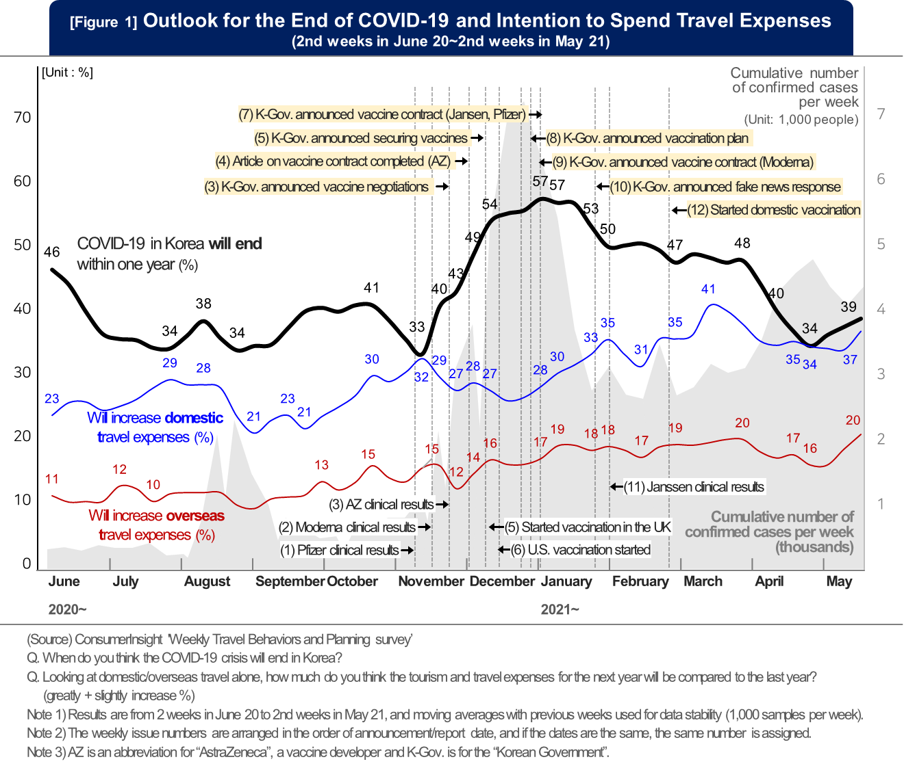
Expectations for ending COVID-19 ‘plunged’
while travel spending sentiments ‘rising’
ConsumerInsight analyzed correlations between the outlooks of ending COVID 19 and travel expenditure
- Prospects for ‘ending COVID 19 in Korea within a year’, retreating to the most pessimistic level
- Prospects for ending COVID 19 turning optimistic or pessimistic by vaccination news
while they used to move aside with the number of confirmed cases
- Hopeful with the news of vaccine development and security but depressed with slow vaccination progress
- Desire for domestic travel recovered to the pre-COVID 19 level, with overseas travel not there yet
Expectations for an end to COVID 19 dropped significantly. The prospect for the ending within a year, which was close to 60% at the end of last year, has recently turned pessimistic, falling below 40%. This change seems to have arisen from the primary concerns of vaccine securing and the slow vaccination rate. Consumers' outlook on the end of COVID 19 was influenced more by vaccine-related news than by the number of confirmed cases. On the other hand, travel sentiments were relatively less affected by vaccines or the number of confirmed cases.
ConsumerInsight, a travel specialized research firm, conducted the 'weekly travel behavior and planning survey' (500 people per week, 26,000 people per year), asking travel consumers about their prospect of the end of COVID 19 and their intention to spend domestic and overseas travel expenses for the next year, and analyzed the results. The research firm analyzed the last 49 weeks' worth of data (2nd weeks in June 2020 to 2nd weeks in May 2021) and applied a simple moving average from the previous week for the data stability.
■ Prospects for the end of COVID-19; Affected more by vaccine issues than the trend of confirmed cases
As of the second week of May 2021 (May 10-16), negative outlooks were greater than positive ones as to the possibility of ending COVID 19 within one year. The response to 'the pandemic will last more than a year' was 61%, while 'it will end within a year' was 39%. The outlook recovered slightly from hitting the lowest level in November last year(33%), but it is still as pessimistic as before the development of a vaccine became visible [Figure 1].
The trend over time shows that expectations for an early end moved 'down-up-down' in order, with the primary factor being the number of confirmed cases. The forecast for an end of COVID 19 within a year around last August was 34% and 33% in November, which was due to the significant increase in the number of confirmed cases after the summer vacation season and Chuseok holiday, respectively.
However, from the end of last year, the prospect was affected more by the vaccine issue than by the number of confirmed cases. Although the number of confirmed cases in the third week of December occurred at a record-high(7,000 units per week), the forecast for an end to COVID 19 within one year was 57%. It increased by 24%p from 33% in the second week of November, which was the lowest level in November, and surpassed the 43% forecast of 'will last more than a year' for the first time by more than 10%p. The expectation for an early end reached its peak with △ the Announcement of vaccine clinical results by global pharmaceutical companies(November 2, 3, 4 weeks), △ the Korean government's successive vaccine negotiations and contract announcement(November 4th to December 1st), and △ news about the start of vaccination in the UK and the US(December 1st and 2nd week).
However, as negative news spread related to vaccines, such as △the vaccination rate outside the top 100 in the world △the supply and demand process, the forecast for an end within a year fell to 50% in the 4th weeks of January, this year, returning to the lowest level of 34% in mid-April. Above all, clearly, vaccines(supply and inoculation rates) have a decisive influence on the dramatic intersection of optimism and pessimism about the end of COVID 19.
■ Correlation between travel sentiment and COVID-19 getting weaker
What would be the correlation between travel sentiment, which has been hit hard after the COVID 19 outbreak, and the prospect for an end to the COVID 19? The willingness to spend domestic travel expenses has risen from 23% in June last year to 37% recently, exceeding the pre-COVID 19 levels (average 35% in 2019). Overall, the spend intention tends to increase when the number of confirmed cases decreases, but the trend shows a slight and steady increase. This indicates that travel consumers are finding new ways to enjoy and consume their own travel even in the COVID-19 situation.
As for overseas travel expenses, the response of 'will increase the expenses' increased to 17%~20% this year from 10%~16% in the second half of last year, but the increase was still less than half, compared to the average of 39% in 2019. Even during the year-end and New Year holidays, when the outlook for an end to COVID-19 increased significantly, the willingness to spend did not improve much, indicating that travel consumers expect that it will take a long time for overseas travel to resume. This is because travel consumers know that even if collective immunity is formed and the end of COVID-19 is declared, many issues need to be resolved, such as the circumstances of travel countries and the recovery of global infrastructure.
The fact that overseas travel will not easily resume even after the COVID 19 ends in Korea and people are allowed to move around suggests many things for people in the travel industry. Overseas travel operators should develop attractive and safe products for consumers who will be anxious even after the end of the COVID 19. Also, in Korea, it is necessary to prepare for the new normal after the COVID 19 by developing domestic travel products like overseas travel.
[Reference] Major announcements related to vaccines (November 2020 to February 2021)
 |  | Contents | Date
(1) | Interim presentation of Pfizer clinical results (prevention rate 90%) |  | 20. 11. 09
(2) | Interim presentation of Moderna clinical results (prevention rate 94%) |  | 20. 11. 16
(3) | Interim announcement of clinical results of AstraZeneca  (prevention rate average 70%, maximum 90%) |  | 20. 11. 23
- | The government negotiating a vaccination contract for more than 60% of the nation |  | 20. 11. 23
(4) | Article on AstraZeneca vaccine contract published |  | 20. 12. 03
(5) | The government announced securing vaccines for 44 million people |  | 20. 12. 08
- | UK vaccination started |  | 20. 12. 08
(6) | US vaccination started |  | 20. 12. 14
(7) | The government announced a contract for 16 million Janssen and Pfizer vaccines |  | 20. 12. 24
(8) | The government started vaccination in February and February next year,  announced targets for group immunity for the third quarter |  | 20. 12. 28
(9) | The government announced a contract for 20 million people with Modena vaccine |  | 20. 12. 31
(10) | The government announced strict response to fake news related to vaccination |  | 21. 01. 24
- | The government announced specific vaccination plan (time, method, etc.) |  | 21. 01. 28
(11) | Interim presentation of Janssen clinical results (85% prevention rate) |  | 21. 01. 29
(12) | Started domestic vaccination |  | 21. 02. 26

Want to know more about #travel issue of this report?

This result is based on the 'weekly travel behavior and planning survey' conducted by Consumer Trend Lab of ConsumerInsight on 500 travel consumers every week (26,000 annual surveys). Weekly updated survey results and analysis reports are available at www.consumerinsight.co.kr/travel, and a summary of the 2020 survey results is also downloadable. (Download report)
ConsumerInsight provides professional and scientific research services required in various industries such as automobiles, mobile communications, shopping/distribution, tourism/travel, and finance through large-scale online panels that are efficient for non-face-to-face research. In particular, ConsumerInsight is currently focusing on increasing data value and applying it to various industries by converging and connecting various big data with panel research data.

Copyright ⓒ Consumer Insight. All rights reserved. Any use of this report for commercial purpose is prohibited.
For-more-Information
Kwon, Younggyo / Director | E. kwonyg@consumerinsight.kr | T. 02)6004-7622

